**Institute of Technology Tralee**

**Ord/Hons BSc. in Computing with Specialism (Group A) - Year 1**

**Continuous Assessment #3**

**Date: 23/4/13**

**Time: 1 p.m. – 3.30 p.m.**

**Object Oriented Programming 1**

**Instructions:** Attempt the following question. You should use the JCreator IDE. When you are finished coding, print out your code in **landscape** format.

**________________________________________________________**

**Q1.**

Write a Java program that contains a JFrame window. This window should contain a label and a text-field. It should have dimensions of 300 x 100 pixels. It should use a flow-layout style and the application should terminate when the close button is hit on its title bar. The label should simply prompt the user for the name of a student. This value should be input by the user into the text-field. When the user hits return on the text-field, having input a name, a **confirm dialog** should get displayed asking the user to confirm whether they wish to enter further names. If the user hits the “Yes” button on the confirm dialog then the dialog disappears, the text-field is cleared and the user can enter further names, however if the user hits the “No”, “Cancel” or close (“X”) buttons on the confirm dialog, then the program will display the list of names the user had entered up until that point on a message dialog, one name per line. Once the user presses the “**OK**” button on this dialog, the program will immediately **terminate**. Your GUI should also have a **tool-tip** added for the prompt label. This tool-tip should just display the text “Enter the name of the student concerned in the text-field”.

Note that hitting return on a text-field constitutes an **ActionEvent**, just like pressing a button, so treat it in exactly the same manner as this code-wise from the point of view of event-handling.

Note that there should be a little **validation** in the application. If the user hits return on the text-field but no value has been entered into it, a suitable **error message** in a message dialog should appear to the user.

You should make use of the **appendix** of method definitions from the X: drive when answering this question.

For full marks your program should, along with a logically correct solution for the problem above, include comments and meaningful variable names.

Some sample runs of the program are as illustrated below.

**Sample Screenshots**

**After launching the application it appears as follows (mouse hovered over the label to illustrate the tool-tip text here)**

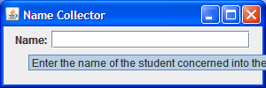

**If the user enters nothing into the text-field and then hits return, a message dialog will appear indicating this problem:**

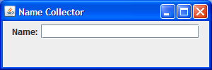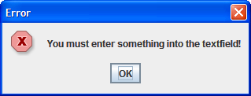

**If the user enters something into the text-field and then hits return, they will be presented with a confirm dialog:**

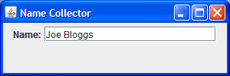 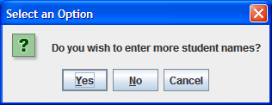

**If the user presses the “Yes” button on the confirm dialog the dialog disappears, the text-field is cleared and they can simply continue to enter more names in the GUI. Otherwise, the user will be presented with a message dialog containing a list of all the names they had entered to that point as follows:**

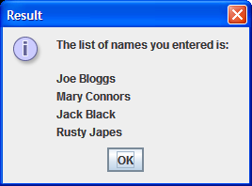

**And once the user hits the “OK” button on the message dialog (or hits return on the keyboard), the program terminates immediately.**